

Practices for Secure Software Report

Table of Contents
Document Revision History 3
Client 3
Instructions 3
Developer 4
1. Algorithm Cipher 4
2. Certificate Generation 4
3. Deploy Cipher 4
4. Secure Communications 4
5. Secondary Testing 4
6. Functional Testing 4
7. Summary 4
8. Industry Standard Best Practices 4

Document Revision History

Version | Date | Author | Comments
1.0 | 03/27/2026 | James Marcano | Completed Project Two secure software report

Client



Instructions

Submit this completed practices for secure software report. Replace the bracketed text with the relevant information. You must document your process for writing secure communications and refactoring code that complies with software security testing protocols.

- Respond to the steps outlined below and include your findings.
- Respond using your own words. You may also choose to include images or supporting materials. If you include them, make certain to insert them in all the relevant locations in the document.
- Refer to the Project Two Guidelines and Rubric for more detailed instructions about each section of the template.

Developer:
James Marcano

Algorithm Cipher

For Artemis Financial, I would recommend using a combination of AES, RSA, and SHA-256 as part of a layered security approach. AES is a symmetric cipher that is commonly used to protect sensitive data because it is strong and efficient. RSA uses a public and private key pair, which makes it useful for secure communication and certificate-based encryption. SHA-256 is not a cipher used to encrypt and decrypt data, but it is still important because it creates a secure hash value that can be used for checksum verification and data integrity.

The bit level of an algorithm matters because it affects how difficult it would be for an attacker to break it. AES-256 uses a 256-bit key and is considered very strong for protecting data at rest. RSA usually uses much larger key sizes, such as 2048 bits, because it is handling public/private key encryption instead of symmetric encryption. SHA-256 produces a 256-bit hash output, which helps verify whether data has been changed.

In this project, secure communication was supported through HTTPS and the use of a self-signed certificate. That certificate relies on key pair concepts, which are part of asymmetric encryption. I also used SHA-256 in the Java code to generate a checksum, which helps confirm that the data has not been altered during transfer.

Overall, I would recommend AES for strong data protection, RSA for secure key exchange and certificate-based communication, and SHA-256 for integrity verification. Together, these methods help create a secure way to transfer and protect sensitive financial data.

Certificate Generation

A self-signed certificate was generated using the Java Keytool and exported as a CER file. This certificate supports secure HTTPS communication in the application. The screenshot below shows the generated certificate file.

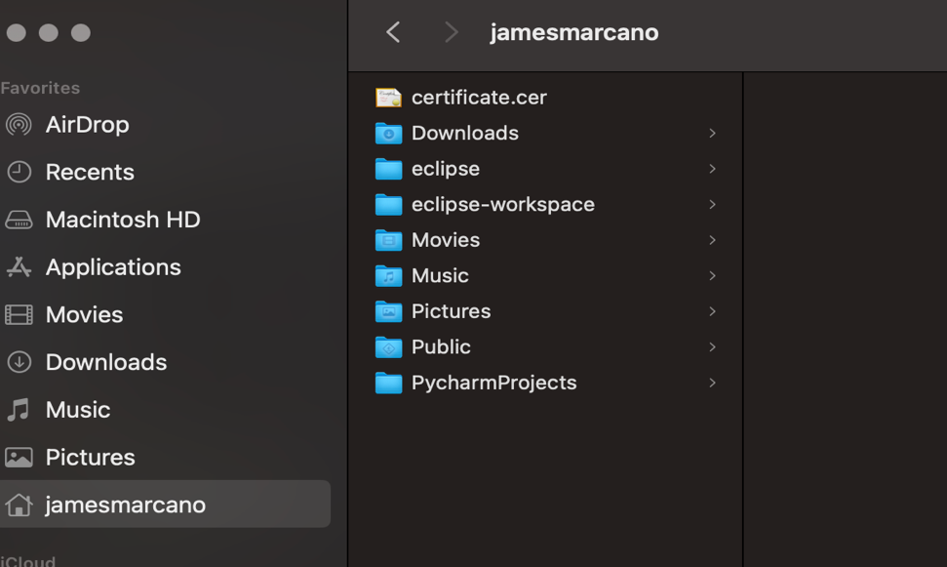

Figure 1. Exported certificate.cer file.

Deploy Cipher

The application was refactored to implement a SHA-256 cryptographic hash for checksum verification. A new endpoint (/hash) was created to return a data string along with its corresponding hash value.

This implementation ensures data integrity because any modification to the original data would result in a different hash value. This allows the system to detect tampering and prevents compromised data from being trusted.

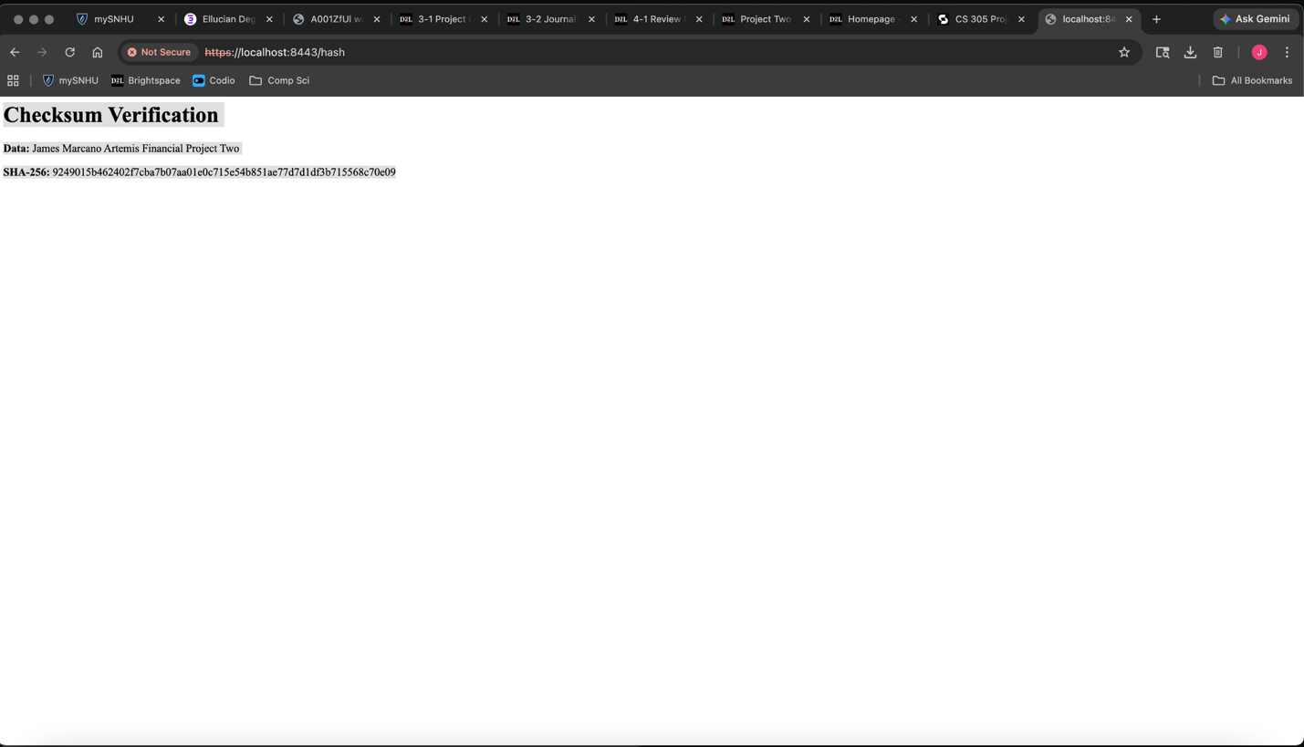

Figure 2. Checksum verification page showing my name and a unique data string.

Secure Communications

Secure communication was implemented by updating the application properties file to use HTTPS instead of HTTP. A keystore file was created and added to the project resources so the Spring Boot application could run securely on port 8443.

The browser displays a “Not Secure” warning because a self-signed certificate was used instead of a trusted certificate authority. However, HTTPS is correctly configured and the data is still encrypted during transmission.



Figure 3. Browser address bar showing the application running over HTTPS on localhost:8443.

Secondary Testing

The OWASP dependency-check tool was executed to analyze the project dependencies for known vulnerabilities. The scan started successfully and showed that the tool was working.

However, it was unable to retrieve updated vulnerability data from the NVD database due to a 403 error. This appears to be an external issue related to accessing the database rather than a problem with the application itself.

Even though the scan did not fully complete, the successful execution of the tool confirms that it was correctly integrated into the project. In a production environment, resolving this issue would be critical to ensure continuous monitoring of known vulnerabilities.

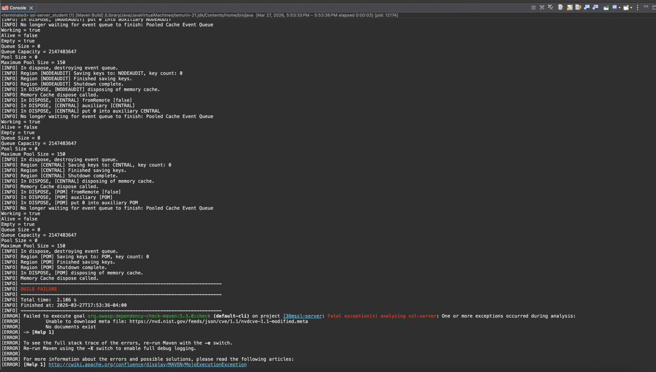

Figure 4. OWASP dependency-check execution showing the NVD 403 access issue during analysis.

Functional Testing

Functional testing was performed by running the application and verifying that it executed without errors. The server successfully started on port 8443 using HTTPS, confirming that the secure communication configuration was working properly.

During manual code review, several potential vulnerabilities were identified. These include lack of input validation and the possibility of client-side attacks such as cross-site scripting (XSS). Although the application is simple, these risks highlight the importance of validating and sanitizing user input in real-world applications.

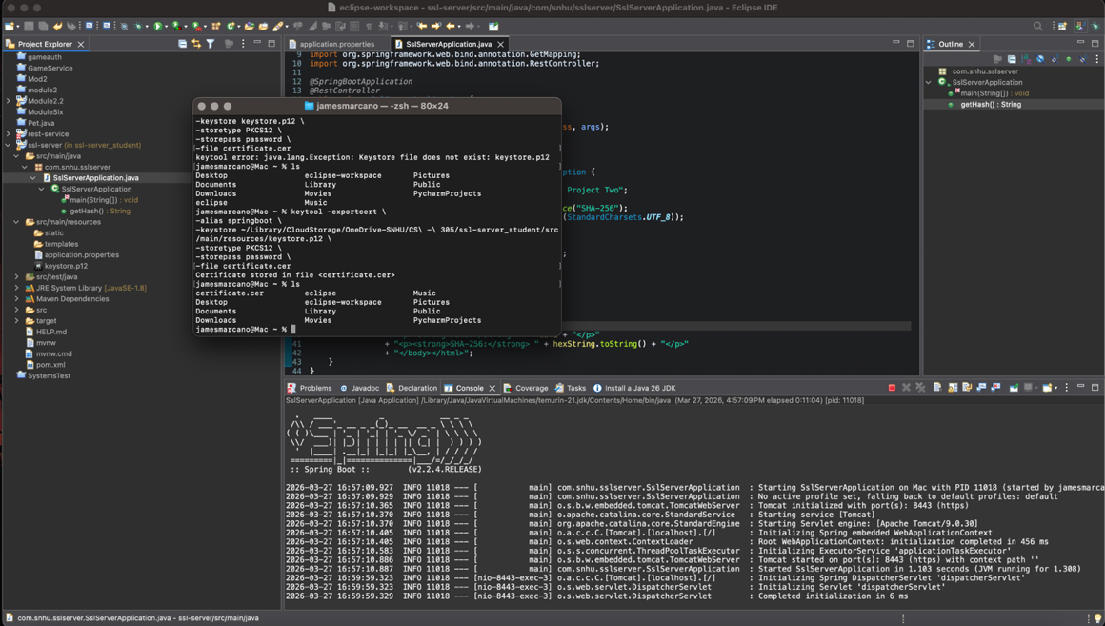

Figure 5. Refactored code and application console showing the project running successfully.

Summary

The Artemis Financial application was refactored to improve security in a few important areas. Based on the vulnerability assessment process, I mainly addressed cryptography, secure client/server communication, and code quality. I updated the application to use HTTPS with a self-signed certificate, which improved secure communication. I also added a SHA-256 checksum feature to verify the integrity of the returned data.

My process started with reviewing the existing code and configuration, then updating the application properties file, generating the keystore, and confirming that HTTPS was working correctly. After that, I modified the Java code to include the checksum method and tested it through the /hash endpoint. I also ran the dependency-check tool as part of the testing process.

Overall, the refactoring added more layers of security to the application while keeping it functional. Even though the dependency-check scan could not fully complete because of an external data access issue, the application itself ran correctly and demonstrated the required security improvements.

Industry Standard Best Practices

Throughout this project, I applied industry standard best practices to improve the security of the application. This included enabling HTTPS for secure communication, using a keystore and certificate for SSL configuration, and using SHA-256 to generate a checksum for data integrity. I also used the OWASP dependency-check tool to review project dependencies for possible vulnerabilities.

These best practices are important because they help protect sensitive information, reduce security risks, and improve user trust. For Artemis Financial, this is especially important because the company handles financial data and needs secure communication between systems and users.

